**Indefensible Spaces**

**Chapter 4 - Policing as Property**

**Rahim Kurwa (rak@uic.edu)**

*This is a draft of Chapter 4 of my manuscript, Indefensible Spaces: Policing and the Remaking of Segregation in the Antelope Valley. The book focuses on documenting the political and social forces in Los Angeles’ Antelope Valley that, in the wake of the Great Recession, attempted to prevent Black residents from moving into the valley through the Housing Choice Voucher Program. The cities of the Antelope Valley found that, in lieu of traditional modes of racial segregation, they could use policing as a mechanism to surveil, regulate, and terrorize Black voucher renters, with the goal of evicting or otherwise forcing them out. Tenants and activists in the valley used local organizing and national fair housing litigation to resist and partially defeat this attempt to re-engineer racial segregation.*

*The preceding chapter traces the evolution of the relationship between race and property rights from one based on the right to exclude via discrimination to the right to exclude via policing.*

*This chapter examines the construction of a policing regime that simultaneously produced the eviction of Black residents and imbued white renters and homeowners with the status benefits of being able to police their Black neighbors.*

*The chapter that follows shows how Black voucher tenants, typically women raising children, experience this policing and attempt to maintain their housing.*

**Chapter Outline**

**The End of Creation** **2**

**Nothing Starts Right Away** **5**

**A Theory of Policing as Property** **12**

**Images** **22**

# 

# 

*“We used to think this area was the end of creation...but it’s home now.” Joe Davies[1]*

# The End of Creation

As the Cold War came to a close, and the nation’s war industries moved on to different technologies and different geographies, the Antelope Valley saw its primary source of economic activity begin to disappear. But the valley’s leaders believed that they could survive it, and that the region had outgrown its dependence on the volatile, contract-reliant aerospace industry, described as a “boom or bust” or “yo-yo” economy in the *New York Times*.[2] By the late 1980s, city officials told the Associated Press that they “see no end in sight to the population boom, which has been fueled by a steady stream of young families fleeing the sticker shock of Los Angeles basin real estate prices.”[3] By then, Palmdale was ranked the fastest growing city in California, and Lancaster ranked fifth. A Palmdale city councilman explained, “Our biggest business is building homes...eighty-percent of the people buying homes are moving up here and commuting.”[4]

In its early years of growth, the valley built housing in service of its economy. Now, the valley had turned that formula on its head, making housing its economic engine. This chapter is about the costs of that transition for the valley’s white polity, for whom the housing fix offered a solution as well as a new problem: a second major wave of Black migration. The prior chapter traced the valley’s unfruitful search for ways to reassert racial hierarchy after the 1960s, and posits that, at a national level, policing became a powerful tool of neighborhood exclusion and eviction. Now, I show how a participatory system of policing was developed in the valley and deployed against incoming Black tenants. While the hostility was broad, it landed on the figure of the “Section 8 tenant” in ways akin to the public disgust aimed at welfare recipients in the 1980s.

When recession hit California in the late 1980s and early 1990s, the valley faced the strongest test of its economic transition. The recession was driven in part by declining military investment, meaning that the valley was particularly vulnerable to its effects. At the time, Palmdale and Lancaster were home to 225,000 people. They lost 40,000 aerospace jobs alone: 1 job for every 6 people. The effects were devastating. The region was described in the press as the “Foreclosure Capital of the United States.” [5]

The valley tried with little success to find other avenues of job creation. Elsewhere in the state, cities were turning to incarceration as a means of creating local employment.[6] The valley struggled to join them. Its oldest detention center, Mira Loma, had existed since 1945, but never represented a steady site of activity or employment. In 1945 it was a vocational school where the California Youth Authority conducted job training for juvenile defenders. About a decade later it was repurposed into a medium security facility, and continued that way until it closed in 1979. It was reopened again in 1983, this time repurposed for female inmates and called the “Mira Loma Female Honor Ranch.” That lasted only a decade, and it closed again in 1993. In 1997, U.S. Immigration and Customs Enforcement acquired Mira Loma for use as an immigration detention facility, which it remained until it was again closed in 2012.[7] Plans to renovate it into a Women’s Detention Center failed and it sat empty. A mile to the north, Lancaster did manage to ride the prison wave, opening the California State Prison of Los Angeles County in 1993. The institution, which cost over $200 million to build, employs roughly 1,500 people, less than 5% of the number of aerospace jobs lost in the 1990s recession.[8]

And so after the crash of the 1990s, the valley rebuilt itself along the same lines it had been pursuing before – mowing down the Joshua trees, paving the desert, and building cheap single family housing. Palmdale and Lancaster both expanded outward and westward – away from the older nucleus of 1950s era homes built by the war economy. New styles, larger plots, whatever it took to convince Los Angeles residents that the commute would be worth it. This time, however, the industry could sell subprime mortgages to buyers who could not actually afford them, using tactics like interest rates that started small and ballooned later. And it worked. Craig, a construction worker in the valley, testified to the crazed market of the early 2000s:

*“Back in the early 2000’s I was delivering roof tile when the housing market was sky high and in 2001 or 2000...I can’t remember exact what year we bought this house, but this house, it was like $190,000 and the prices were going up. Like every week the prices were going up. If we wouldn’t have qualified for this house I think our – the most I qualified [for] was like $195,000 and this house was $190,000 something. If we wouldn’t have qualified for this one houses this size would have been $200,000 after. I was busting off my ass off, man, I was working 60-70 hours a week.”*

In the meantime, lending banks chopped up and sold these subprime mortgages to other banks and financial institutions. The financialization of the boom helped get thousands of Angelenos situated in the desert. It also ensured that when the unpayable payments began coming due, the consequences would be widespread and devastating. Once again the Antelope Valley became a foreclosure hub: at the peak of the 2008 foreclosure crisis, Lancaster and Palmdale occupied two of the top three spots in the ranking of California cities by foreclosure rate.

It is into these circumstances that Housing Choice Voucher tenants were moving. As the program grew nationally, the valley saw its total number of residents in the voucher program grow from roughly 5,000 in 2000 to just over 10,000 in 2006, and over 15,000 in 2016. They came because the economic structure of the voucher program gave them little choice. The price that the county would pay to landlords on behalf of voucher tenants (the fair market reimbursement rate) was calculated over the entire county. That meant that it was too paltry to convince landlords in wealthy areas to accept it, and so generous that landlords in struggling neighborhoods often affirmatively searched out for it. Because Antelope Valley rents were roughly 1/5th lower than rents in the rest of Los Angeles County, the geography of available rental units for voucher tenants skewed towards the valley.

Like so many others, Craig purchased his home in the valley at near the maximum of his credit range and just as the market was beginning to peak. This made him especially vulnerable to the recession. When the housing market eventually crashed, Craig’s own fortunes took a downturn, as he no longer had much work delivering roof tile. His family lost ownership of their home in 2009, but, as he put it, “we’ve just been here, they haven’t foreclosed yet.” He compared his situation to that of the average Section 8 renter, speculating that those renters would be more attractive to landlords because their rents were guaranteed by the government while his ability to make rent depended on getting a steady income.

*“Say they foreclose on me and I gotta move out. I got no – I went bankrupt, I got no credit, I got really nothing. I work and my wife works, but someone that has a house that’s gonna rent it out to me; would they rather rent it out to me when they don’t know me from Adam, or they’ll give it to some guy that has Section 8 because they know they’re gonna get the money from the government?”*

Craig knew that his economic position put him at a disadvantage compared to voucher tenants, whose rents would be paid on time every month. To a landlord his economic precarity would make him look like a risk. But the idea that he too could sign up for a voucher never came up. Perhaps he knew, as I did, that the waiting list was closed.

Between 2011 and 2014, I interviewed 43 voucher tenants in the Antelope Valley. Many voucher renters I spoke to came to appreciate the valley after they got there – I did too – but none that I spoke to said they had wanted to move to the valley when they got their voucher. People did it because they needed a place to live. When they received their voucher from the Housing Authority of the County of Los Angeles, either they were given a list of landlords willing to rent to them, or openings were taped to the walls of the housing office, or they checked a website marketing listings to people with vouchers, or they set out on their own to find a landlord willing to rent to them in the sixty-day window tenants have to secure housing. One way or another, tenants found that they definitely could use their vouchers in the Antelope Valley, but that it would be harder to use the voucher elsewhere.

As they arrived, they often moved into the homes that had been built for the white workers staffing the aerospace economy of the nascent Antelope Valley, built at the request of the military and its defense contractors, and with the kind of federal financial backing that was never to be made available to Black families. What started as public housing had become so again, and in so doing re-inscribed the military’s role in shaping Black Los Angeles’ geography – from the former military barracks that became public housing in the city to the military’s wartime investments in suburban homes in the desert.

# Nothing Starts Right Away

Racial backlash theory in the social sciences generally defines the term as “the politically and electorally expressed public resentment that arises from perceived racial advance, intervention, or excess.”[9] The concept suggests an acceptable status quo ante in which backlash is not present; this is then disrupted by social change. One voucher tenant I interviewed, Nate, reflected on the contemporary politics of the valley in a different light:

*“Nothing starts right away, so it must be something that's been lingering along going out here, and people that's been out here since the late 70's, 80's when it was unincorporated that's pretty much ran the town. So, you probably have generations of people who have those type of racist views that instill it in their kids and their grandkids and their grandkids.”*

From this perspective, the backlash to voucher tenants is better understood as the continuation of a longer struggle over racial hierarchy in the Antelope Valley. The terrain of the struggle had shifted the voucher program, but the stakes for white and Black residents of the valley remained the same.

Linda, one of the oldest homeowners I interviewed, lived in one of the neighborhoods built in the 1950s, and which had recently seen a relatively high rate of voucher movement (by this I mean it's likely that one or two tenants were in her vicinity). She hated the program, and like Nate had speculated, she anchored her understanding of it in the fight her community had lost fifty years prior.

*“There was a community east of Palmdale called Sun Village. In those days, most of them lived there. Now the people who were here then, the black people, they were high-class people. I mean they didn't go around selling drugs and getting in jail for the most part, at least the ones I knew. And the children, not many, were here in school but the ones that were, were very nice. Then came – I think the riots in LA in 1966. That was the first indication I had of how horrible it really was...”*

*“Well, I can just tell you that for the first time a Black family moved into this neighborhood, there went the neighborhood. And that was about 1988, I think. I know [that] was not the first family. We had a lovely family, they owned a religious bookstore…*

*I think it was a law passed that there had to be a Black family in every block. They were gonna put a Black family in every block in Lancaster. That started during the '60s. This was the NAACP. And they did it.”*

From the historical injury of civil rights, everything else follows. The destruction of her neighborhood wasn’t triggered by the decline of the aerospace economy, but by the mandated placement, as she remembered it, of Black families on every block. Linda’s interpretation calls to mind the twisted name opponents of Fair Housing used in the 1960s - forced housing.

Another longtime resident I interviewed was Dorothy. She arrived in 1958, boom years in the valley. When I asked her about the voucher program, she threw it back in my face.

*“I'm here fifty-ish years, tried to make it at home and how do you think I feel when I see some of these people that their Humvee's sitting in their yard and not in their garage at the Section 8 houses over there, and $300.00 - $400.00 for a $2,500.00 a month house? To me, that is a problem.”*

Dorothy did not offer a substantive reason to believe that the neighbor she was speaking about actually was using a housing voucher. But even assuming she was correct, we can reverse engineer the set of conditions under which she would accept the tenant living on her block - in this case perhaps if a voucher tenant drove a sufficiently cheap car, or hid it so as not to offend anyone. But Ashley opposed the voucher program “[b]ecause when you see someone who's able to buy a lobster because they don't have to pay rent...I don't get lobster.” Add “no lobster” to the list of acceptable conditions for voucher residents. Another local resident surmised, “They're just kinda – I don't know. They feel entitled, I think.” Add to the list, “don’t make people feel like you feel entitled.” Dorothy claimed, “they're living in better houses than we are.” It’s not hard to see where this is giong: there was no correct way to be a Black voucher tenant in the Antelope Valley.[10] One voucher renter I spoke to named the futility of trying to fit in: “They don’t want you next door for some reason. No matter how gracious you are.”

Michael was among the respondents who spoke the most extensively about his attitudes towards voucher tenants. When I asked him about his attitude towards the voucher program he explained “...it's not the Section 8 woman that lives there. That's fine and all that.” But as he continued speaking, this sympathy quickly melted away.

*“But it's all the fucking riff-raff they bring with them. All the 98's that come up here from LA and hang out in the yard and fucking barbecue, couches, all that shit in the front yard.”*

*RK: - What's a 98?*

*Michael: Ninety-eight is security code for blacks...it's not like saying black. You know what I mean?...It's a neutral term.*

*RK: So you're saying that the tenants can be good but there's other people that come in with them –*

*Michael: Tenants can be okay, like it's just the momma and the little couple of kids or whatever, that's fine. But that's not what you get. You get all the cousins staying overnight, you get the drug dealing, all the bullshit. I've seen them. Go down to the Section fucking 8 office and watch them...Watch it. Watch what happens. You can see them all. They're all the same size. They all eat the same. Go ahead.*

*RK: And this is based on your personal experience –*

*Michael: It is the fucking reality! My experience is reality.”*

Michael started by dividing voucher tenants into good and bad – the good mothers who unfortunately can’t be tolerated because of the bad people around them. But within a few sentences he said what he really thought – go to the Section 8 office and look at the tenants. These types of surveillance urges are central to producing and acting upon hostility to Black residents.

Michael went on to focus on Black mothers, who are in some ways the face of the voucher program. He commented on their cooking and their dietary practices, suggested they were “professional” welfare recipients, and claimed that voucher holders simply “wait about four years and then squeak out another one, so they can always stay on the program.” These comments are echoed by other respondents who comment on voucher tenants’ sexual practices, number of partners, manipulation of pregnancy or disability to qualify for welfare or housing support, and parenting practices. One explained the program by saying, “"If a woman gets pregnant and has a child she has everything paid for. Her boyfriend lives in the house. They get [a] free house. Free rent. If she goes to college they get more money, and they have another child, more money and they get this, that and the other.” In another interview, a respondent echoed the welfare queen myth, stating that they opposed the voucher program because “my friend goes and gets her welfare check and she sees people pulling up in their Escalades to go collect bills." It was Pete Knight’s anti-immigrant song sung in the key of anti-Blackness.

These attitudes are consonant with many of the other local residents I spoke to, and with a half century of how policymakers have thought about poor people, poor Black people, and poor Black women and mothers in specific. Just as policy makers have used these ideas to dismantle the welfare state and fuel mass incarceration, the Antelope Valley searched for ways to materialize its opposition to voucher renters. Central to this was Lancaster Mayor Raymond Rex Parris Jr.

Rex Parris, as he would come to be known, was born in Palmdale in 1954. He recalled to me the arrival of a Black family in the neighborhood, saying,

*“An African American family moved next door to us. And my parents were the only ones to go over and meet them, you know, bring the traditional pie or whatever [it was] you do to welcome people when they moved in...But the rest of the neighbors were really upset. But I think they were more upset about the impact it might have on home values.”*

Although his father left the family around this time, community ties and economic support were strong. The household sometimes relied on welfare assistance to get by,[11] and others in the community stepped in to assist the family: “...You know, Howard Bullard was his name, essentially stepped into that role for a while taking us to the snow and doing stuff like that you do with kids.” As a young person, he suffered from severe social anxiety, but he overcame it in high school, running for freshman class president and remaking himself as R. Rex Parris. He went on to UC Santa Barbara and Southwestern Law School, returning to Lancaster to begin a personal injury firm. Parris’ advertising strategy was simple - be the first thing everyone sees when they get to the valley. He purchased billboard advertisements targeting motorists driving into the Antelope Valley on Highway 14, and has kept a steady cycle of them for years. In that time, the firm has become highly successful, providing Parris the funds for a successful run for mayor in 2008. Although he began his mayoralty focused on gangs, his focus quickly turned to voucher renters.

In a 2008 City Council meeting, Parris announced that it was “time to go to war” against Section 8. “Make no mistake,” he told the audience, “this City wants to limit the number of Section 8 units that are placed in this community” (City of Lancaster, 2008).

To legitimize efforts to stop voucher renters, Parris asked the Housing Authority of the County of Los Angeles for data on the “impact” of voucher renters on the city. When told that no such data existed, he explained, “I'm more interested [in] what the neighbors think. I mean, we're assuming that these homes are having a detrimental impact on the morale of the neighborhood, for lack of better word, for the character of the neighborhood (Blasi 2011).” But as Parris told me years later, there was simply no evidence that voucher tenants had a detrimental effect on the valley. “There was one and a half percent of this, actually, people who were creating problems. That was all, yeah.”

Nevertheless, by 2009, Parris was publicly expressing frustration and the city’s inability to curb the program. In the city council’s March 24 meeting, he had the following exchange with City Manager Mark Bozigian,

*Parris: I am tired of working with these people. I want to see those numbers drop. I want us to be proactive in dropping those numbers...I want us to set the goal in this City of how many thousands of Section 8 we are going to get rid of, and then we can at least start being, be accountable to ourselves as to whether or not we are moving in that direction. What I [am] unwilling to do is talk about this anymore. We know as much as we need to know. Let’s figure out what the number, this is the number we will reach, and then we will be able to evaluate if we are doing things in a direction that is moving us into a successful conclusion. ..... And I think we should be absolutely honest and transparent, or whatever word you want to use, to the entire world: we are going to get rid of this many, this number, Section 8, from our community, and that is what we will devote all of our efforts to until it happens. When can I have that number? When can you present something to the Council that this will be the goal of the City?*

*Bozigian: We could do that right now. Our goal, initial goal, is to get down to the County average, which is half of what we’re at right now.*

*Parris: So now we know that the goal of this City is to get rid of half of the Section 8, right?*

*Bozigian: Yes. (Blasi 2011)*

Lancaster began trying a series of strategies to achieve its goal of reducing the voucher population. One idea that Lancaster and Palmdale jointly explored was to split from the Los Angeles County Housing Authority, escaping their jurisdiction and allowing them to limit the number of voucher tenants who could move to the valley from Los Angeles. The strategy was the reverse of a quiet trend happening in Los Angeles, where tenants under the City of Los Angeles’ Housing Authority were “porting” their vouchers to the County’s Housing Authority to give them more access to available rental units. In 2008, Lanaster established a Section 8 Commission to look into the feasibility of creating its own housing authority. Ultimately, the strategy was dropped, because it was too expensive and administratively complex to create a new housing authority, and because departing from HACoLA would mean forfeiting tens of millions of dollars in other forms of housing assistance funding.[12]

Another idea was to find ways to limit the supply of available rental housing that could be rented to voucher tenants. If it could not find practical ways to prevent voucher renters from choosing to move to the valley, it could restrict the ability of property owners to rent to them. The city passed a Rental Housing Business License ordinance in 2007 that made all owners of rental properties acquire licenses from the city.[13] To acquire a license, property owners had to agree to be subject to inspections by the city. With the license system in place, the city looked into the viability of capping the number of business licenses issued for rental properties. Since business licenses for single family homes would be used almost exclusively for renting homes either on the private market or to voucher renters, this strategy would have meant an effective one-year moratorium on any new Section 8 rentals in Lancaster. A one-year moratorium on business licenses for single family homes was proposed in 2009, but not enacted. The city would later return to this strategy of supply-side enforcement through the municipal code structure. This reveals a novel mechanism for local governments to restrict voucher renters from moving in. Rather than pass discriminatory policies that could be read as such and be struck down by a court, this strategy simply shrinks the possible supply of rental property by making business licenses a necessity and then capping them to restrict growth. For a city so dependent on its homeowners to consider curtailing their economic power during an economic crisis suggested just how important curtailing vouchers was to its leadership.

Lancaster and Palmdale also considered a plan to steer voucher renters away from the valley and towards other locations in Los Angeles County. As Parris told me, “I was deliberately saying things to discourage people from moving up here on section eight. I thought we were getting our unfair share of them.”

Parris’ statements were one thing, but Lancaster’s Section 8 Commission asked HACoLA for permission to make presentations to voucher renters, and included police and code enforcement officers in the planned presentations as well. The presentations were intended to “inform them of what the cities expect from them as residents of both cities.”[14] The content of the presentations was a stream of negative information designed to persuade renters not to rent in the area. One example included emphasizing high costs of home heating and cooling that voucher renters might not consider when looking at the cost of renting in the valley. Although the matter was discussed seriously, HACoLA ultimately declined the requests. The cities also asked HACoLA to “produce an ad campaign to dissuade voucher participants from moving to the Antelope Valley by falsely suggesting that there were no jobs, no services, and that the cost of living was high.” This too was declined.

A final strategy floated by the city in its efforts to restrict voucher renting was to direct enforcement through schools. In 2010 the mayor proposed to HACoLA that the City could begin a program whereby voucher renters with children would have their vouchers revoked if their children missed school. The plan was brought up multiple times. In an October 26, 2010 city council meeting, Parris formally proposed it to a HACoLA administrator. HACoLA responded by saying it had no authority to terminate the vouchers of parents whose children were truant. The City also pushed for state legislation that would empower HACoLA to terminate parents of children who missed school; HACoLA’s response was that it had no interest in such legislation. "Some district attorneys' offices actually bring child-neglect charges" Parris argued, implying that the practice could be seen as a precedent to follow.[15] In 2011, Lancaster officials asked State Senator Sharon Runner (R-Lancaster) to write legislation that would allow housing authorities to terminate vouchers based on children’s missed school.[16] Runner filed SB 660 in February 2011. The bill received a negative analysis and did not pass.[17]

This series of dead ends might appear to be failures, but the message they sent to the valley was clear. To private renters and homeowners, it kept the issue alive in the papers on a regular basis, constantly focusing attention on the tiny percentage of valley residents using the voucher program. To those residents it put them in constant fear of eviction. As avenue after avenue proved fruitless, the city consolidated its efforts around policing as a way to govern and remove voucher tenants, and restore the lost social status of private renters and homeowners.

# A Theory of Policing as Property

The turn to policing began with Lancaster, Palmdale, the County of Los Angeles, and the Housing Authority creating a new enforcement program focused on voucher tenants. But it evolved into a form of participatory policing, wherein residents of the Antelope Valley were enfolded into the work of policing their neighbors.

Thinking about policing as something that individuals acquire and do represents a shift in the conception of property and property rights. Residents I spoke to – often but not entirely white – routinely spoke of the voucher population as double, triple, or quadruple its real size, expressed fears that their community was being overrun, and despaired over the changes they and their leaders apparently would not or could not stop. They were losing something they felt belonged to them, and feeling the value of what they had left diminishing. Policing their neighbors was a way of re-establishing the value of their property – not just in the monetary sense but in the sense of meaning, rights, and powers that are bound up with property ownership.

To more closely examine the premise that policing can exist as a form of property, it is useful to revisit Cheryl Harris’ groundbreaking “Whiteness as Property.” Harris makes the convincing argument of the title’s premise by measuring whiteness against traditional markers of the definition of property. Following Harris’ method, the first definition of property states that something is property if one has the right to use it. The second metric is conference of status: something might be property if owning it confers a different status upon its owner. Third, something might be property if one can exclude others from its use.

This chapter will demonstrate that policing is a usable tool, and that to participate in policing is to embody a meaningfully different social status. Policing reasserts a status hierarchy that disappeared when the neighborhood integrated. Voucher renters are excluded from policing because they believe their calls will go unrespected, or that even requests for service will be seen as police interactions that might lead to eviction. And at a collective level, the use of policing by a neighborhood can lead to the literal exclusion of voucher renters from that neighborhood. At the base of it all, however, was an enforcement program created in partnership between Lancaster, Palmdale, HACoLA, and the Los Angeles County Sheriff's Department to target voucher tenants for additional inspections. The enforcement program included mechanisms by which local residents could participate in that policing.

The enforcement program was built when Parris and the Lancaster City Council entered a Memorandum of Understanding to pay HACoLA $50,000 in exchange for 2,080 hours of administrative time over a one-year period, targeted towards the voucher program. Palmdale also participated in the program. In 2009-2010, Parris expanded the Memorandum of Understanding undergirding this relationship such that Lancaster paid $121,266 for expanded investigations of voucher renters. This was matched with $284,000 from County Supervisor Mark Antonovich. This funded the salaries of inspectors and analysts whose job was to visit the homes of voucher renters to perform spot inspections of units for violations of HACoLA rules and city laws. This enforcement staff was given office space in the Los Angeles Sheriff's Department stations in the Antelope Valley. (There is no local police force in the Antelope Valley: rather these services are contracted out from LASD.) LASD officers accompanied the inspectors on their visits. HACoLA used its administrative time to liaison with the cities’ enforcement program, providing the inspectors with names and addresses of voucher tenants in the valley. As Gary Blasi, Professor of Law at UCLA and a key figure in the effort to end the policing of voucher tenants, explained,

*“...[T]hey were basically supplying them a target list once a month. Like, these are the people you should be harassing now. I don't know what else they told them, but they told them anywhere they lived. They knew everything about them, because they had their files.”*

The inspection regime was brutal. “...[A]nywhere else in the county, if they were going to do an inspection, they were civil about it.” Blasi said. “They would make an appointment to come talk to you and that sort of thing. They didn't surveil you as [the Antelope Valley fraud inspectors] did. I mean, literally, they did stakeouts on people to see if some guy showed up.” The system was not confined to trying to find reasons to evict tenants based on purported violations of their rental contracts, it extended to terrorizing them as well. Speaking about fraud inspectors’ practices of parking near voucher tenants homes to surveil them, Blasi surmised,

*“He was probably there to signal that people were being watched. And that's the way that stuff works. It isn't what they actually do, so much as what they communicate that they're going to do. So you have this anxiety all the time, and it's very stressful. Particularly when he's talked about Child Protective Services, and the implication that not only we're going to evict you and make you homeless, but we're going to take your kids away from you.”*

But the cities extended their policing of voucher tenants beyond the new investigatory staff and Sheriff’s department deputies detailed to this work. They began to make a concerted effort to involve residents of the Antelope Valley in the policing of their neighbors. This participatory policing had several advantages: it expanded the number of people surveilling and filing complaints about voucher tenants far beyond the government’s capacity, it satisfied angry residents and gave them a sense of empowerment (rebuilding the lost morale Blaci referenced earlier), it allowed for discrimination to run rampant as long as it was being done by everyday citizens, rather than the government, whose role was simply to accept and investigate complaints, and it offered the possibility of evicting voucher tenants and resisting the integration of once-white neighborhoods.

In newspapers and online, people spread the word about the HACoLA Fraud Hotline, a number that anyone could call to report a voucher tenant’s suspected violation of Housing Authority rules. Around this time local residents started a Facebook group called “I Hate Section 8,” in which they would discuss the program, denigrate its participants, encourage policing, and doxx suspected voucher tenants. Even on a mundane website like city-data.com, where people generally carry on unremarkable discussions about their cities, ask and answer each other’s questions, and share trivia, threads could become singularly focused on the voucher question. Posters discussed where to live in the valley that would have no Section 8 tenants, bemoaned the waiting list being reopened, discouraged their peers from renting their property to voucher tenants, and encouraged each other to report Section 8 tenants to the program’s fraud hotline, even without proof. A user employing the name of the city’s lead voucher fraud inspector, Gary Brody, replied to comments about the voucher program with reassurances that he was leading the efforts to police voucher tenants and encouraging angry residents to be patient as the system worked to remove them.[18] As a voucher tenant named Andrea described, these ideas were present in the media as well:

*“But [its] the whole culture of the Antelope Valley. You can go to the AV Press any day of the week and you might see something, if you feel like somebody on your street is on Section 8, call this number and you think they’re not complying. So that starts with them. Then you hear the city officials talk like that. Then you hear – when I say hear, you see them on T.V. You hear them in the newspaper. So that’s what kind of culture we live in.”*

The results were predictable. In 2008-2009 for example, 414 calls were made to the fraud hotline regarding voucher tenants in the Antelope Valley, 40% of the total 1,084 calls made across the entire county in the same time period. It was a remarkable sum given that the valley was home to just 17% of the voucher tenants in the County.

What accounts for such enthusiastic participation in the policing of one’s neighbors? By creating pathways for individuals to participate in policing, the Antelope Valley was making policing into a form of property. Policing restored the right to discriminate which was so diminished by the Fair Housing Act. And that right is one with powerful implications for the symbolic value and meaning of property. Being able to police elevated the status of those who possessed that power. Actually engaging in policing took that process farther, because it also diminished the status of those being policed. And successfully policing a Black voucher tenant out of the neighborhood was perceived to be beneficial for property values. It is not just that policing related to property values, or that policing became a right held by residents, but that it functioned like a form of property. This perspective does not rely on the attitudes of white residents (though they were overwhelmingly hostile to voucher tenants); rather, it explains their actions by considering what was materially at stake for them. Finally, it is worth noting that this strategy also allowed for the valley to crack down on voucher tenants without encroaching as directly on property owners as had been contemplated in the proposal to restrict rental properties.

The “war on Section 8” was a war to regain property by dispossessing voucher tenants. The city paired the creation of enforcement capacity targeted at voucher tenants, with legal moves empowering residents to file complaints against their neighbors. This moved the locus of discrimination down from the city itself to the individuals enforcing city rules. The system, according to The Community Action League (TCAL)’s complaint, originated “[a]fter Lancaster‘s mayor specifically asked the City Council to ―[l]ook into a means for making it very easy for neighbors to file nuisance lawsuits with the assistance of the City against...Section 8 housing.”

The city’s nuisance ordinance provided “enhanced penalties where there are multiple calls to the police or public safety entities for service – even where there is no actual criminal activity” (The Community Action League et al. v. City of Lancaster and City of Palmdale 2011). The ordinance defined nuisance as:

*[a]nything which is injurious to health, or is indecent, or offensive to the senses, or is an obstruction to the free use of property, so as to interfere with the comfortable enjoyment of life or property by an entire community or neighborhood, or by any considerable number of persons.*

This broad definition is not unique to Lancaster, but clearly can be used maliciously by anyone seeking to punish a neighbor based on a subjective interpretation of the code.

Finally, and perhaps most importantly, the municipal code was also amended to state that if a rental unit was the subject of five nuisance complaints in one year, both the tenant and the landlord would be subject to fines and other penalties, which the landlord could avoid by evicting the tenant (The Community Action League et al. v. City of Lancaster and City of Palmdale 2011).

The logic of the ordinance is captured in the minutes of a 2008 Code Enforcement Commission meeting. The minutes recount comments made by City Councilmember Sherry Marquez,

*It is time to take the neighborhoods back and make them a safe and quiet environment once again. If people are defrauding the system, they need to leave now because Lancaster will not stand for this anymore. [Marquez] stated that the City Council approved the introduction of a Nuisance Ordinance at their last Council meeting and that this ordinance will be a great tool to help the City move forward and she provided some statistics regarding Section 8. The Commission should look at trying to accomplish several steps such as how Section 8 works; encourage neighborhood watch programs; the Commission will be the face of the community (Blasi 2011).*

Here the city essentially states its intention to partner with local residents to police voucher renters, both through setting up a system whereby individuals can make complaints that result in severe enforcement and by encouraging the creation and use of neighborhood watch programs under the broader context of this policing. To really bring it all home, the city created a “Good Neighbor Guide” which informed residents of the municipal codes, gave them examples of complaints they could make, and walked them through the process of making a complaint. The guide told residents,

*When a problem landlord, tenant or homeowner becomes responsible for five or more nuisance calls within a 12-month period, each additional call will entail a stiff penalty of $1,000. When a neighborhood has a persistent problem, residents now have the ability to hit the property owner where it hurts, in the pocketbook (City of Lancaster 2009).*

This helped to ensure that the changes were not just made in the law, but that local residents opposed to Section 8 knew about them and knew that they should take advantage of the new codes.

Some local residents were clearly empowered by the city government’s hostility towards vouchers. Jim is a retiree who had moved to Lancaster after leaving the Navy in the mid 1970s. In my conversation with Jim he explained how reassured he felt by Parris’ election and his efforts to give citizens more abilities to police their neighbors:

*When we got R. Rex Parris in office that was the change up time because he stood up to the mongrels. He stands up for what he believes – he's against Section 8 himself and bottom line is he's got the Sheriff’s department working with him where – I got a Deputy Sheriff on speed dial on my phone. I call him every time I've got a problem on the block. I don't put up with no crap.*

One can easily read this in the language of property by seeing how acquiring more ability to police translated into increased status for Jim. The city and its racially hostile local residents fueled each other, with city officials engaged in racist and anti-voucher speech and implementing vicious tactics to evict tenants, and local residents supporting the city ever more while feeling empowered to take the law into their own hands. They did so by surveilling neighbors they believed were using vouchers, dispatching police and city agencies to visit their homes for possible infractions, and directly confronting voucher tenants to assert their preferences and control over the neighborhood. The actions are legible from the lens of policing as property.

When private residents interact with voucher tenants, it is from an assumed social position of superiority, rather than as neighbors. Patricia, a middle-aged Black tenant explains,

*“When I came up here, people don’t speak to you...they’re really disrespectful. When you do speak to them, they try to figure out why you’re speaking to them...they treat people however they want to treat them, they talk to them however they want to talk to them.”*

Andrea describes her neighbors in a similar light: “My neighbors haven’t been aggressive towards me or my family, but they’re not very friendly...Just – they’re very cold if you speak to them. Many of my neighbors turn their head. I’m like, oh my God. What was that about? Did I do something wrong?”

In the following passage, John describes a moment in which a local resident made over this resentment of voucher tenants for their receipt of government support :

*“And I’ve actually been in a conversation – well, in the midst of a conversation where somebody told me, like – well, not told me, told someone else, like, well, you’ve got this big house. I know you’re paying maybe $400.00 for rent. You know what I’m saying, I could pay your rent. Versus at my house, I got to pay $1600.”*

These interactions demonstrate two processes occurring at once; the denigration of Black residents of the neighborhood is tied to the assertion of a superior social status of private renters and homeowners. But it can be furthered not just through snide glances and rude speech. These private residents can engage in policing as a means to even more materially elevate their social status while diminishing that of the voucher tenants they despise.

This is one reason why residents participate in policing. With participatory policing, local residents are enfolded into the act and practices of policing by their local government. It represents a synthesis between the mob and the state, in which the state empowers residents to act in ways that it knows are racially discriminatory but which it can claim to simply neutrally respond to and enforce. Local residents are empowered to participate in this policing because it furthers the ends they are invested in - removing Black residents from the neighborhood and asserting their superiority to them.

Something is property if its possessor can use it, and local residents used their ability to police to surveil the neighbors who they believed were voucher renters, using crude race-class shorthand. The surveillance practices themselves delivered a first blow to voucher tenants, making them feel watched and unsafe in their homes and neighborhoods. Alicia explained her experience as a voucher tenant. At the time of our interview, her neighbors did not know she was a voucher renter. Nevertheless, she explained:

*“They stare. They call the police for anything. Not on me but my neighbors across the street...they call the police on them like if they park their car in front of the mailbox, they call the police. That’s ridiculous. They have too many cars in their driveway, they call the police. That ain’t your business.”*

Another voucher tenant explained that they experienced surveillance by neighborhood watch, rather than just individuals acting alone:

*“There’s something like – what is it? Not the policemen, the watchers. So for any little thing, they want to make a complaint, you know. They must want to get rid of us. They pretty much disagree with a lot of us that are on section eight. You know, like I said, that’s because they think that we’re minimal or less of a person...”*

As these tenants attest, the purpose of surveillance is to generate opportunities to file complaints, call police, and otherwise trigger moments of state intervention that might result in the eviction of voucher tenants.

# 

Only a small number of local residents actively investigated which of their neighbors might be using a voucher. But by sharing this information with neighbors either informally or through the neighborhood watch, they effectively expanded the effects of surveillance much farther. These activities helped some residents reassert a feeling of control over their surroundings and laid the groundwork for further policing.

In multiple cases, respondents being interviewed at their front doors would point out the homes on their block which they knew were rented to Section 8 tenants and describe something about the tenants who lived there – whether they were noisy, how recently they had moved in, why a rental unit might be vacant, and so on. Jim explained in detail the various strategies he employed to identify voucher tenants:

*RK: And how do you know when a house is Section 8?*

*Jim: How do I know? First place, I know every owner of every house in this block and I've got their number. And when someone rents a house and moves in, I ask them.*

*RK: Okay. You ask the renter or the –*

*Jim: I ask the owner. Is this Section 8 or are you just renting it out?*

*RK: Oh, okay.*

*Jim: And you can always go to the courthouse and find out if it's a Section 8 rental or not.*

Jim later explained that he not only worked hard to know when and where voucher tenants were living in his neighborhood, but that he actively worked to organize his community to be aware of and assist in monitoring these tenants. This type of information sharing was not uncommon. Russell, a retired-by-layoff former aerospace employee who had been transferred to Lancaster by his former employer in the 1990s, explained how he benefited from these surveillance networks:

*Russell: ...We have a neighborhood watch here, one guy, and he always knows what's going on all hours of the night.*

*RK: Oh, okay. So he kind of keeps an eye on things?*

*Russell: Yeah. Makes the complaints.*

Russell did not need to go to the same lengths as Jim to discover voucher renters because he actively benefitted from one of his neighbor’s efforts to collect that information and share it amongst local residents. In this way, residents like Jim had an outsized effect on the neighborhood, as their information diffused through networks such as pre-existing friendships between long-time residents or organizations like the neighborhood watch. These networks provided Russell with enough information to allow him to stand at his doorway and point out the homes within eyesight he claimed to know were rented by voucher tenants – adding the tidbits of information he knew about the renters as well.

In some cases, this surveillance and coordination operated through the local neighborhood watch, which served as both an information exchange and a tool of intimidation. Jim explained that they played a symbolic function, “I'll do anything I can to keep the signs up because that's a good preventative.” Although he was frustrated by the scope of territory that required surveillance and disappointed that public participation was inconsistent, Jim remained adamant about doing his part, saying “I walk my block once a day or twice a day,” and added that he would always watch the houses of those who made a good effort to participate in the neighborhood watch. In an interview conducted down the street, another respondent referenced him as a source of information about voucher tenants, an active monitor of the block, and a person who could be relied upon to call the Sheriff’s department or city’s code enforcement office. Another older resident on a different block expressed thanks for the good people on her street that monitored the “comings and goings,” again suggesting that while only some residents engaged in very active surveillance efforts, their work had wide effects and was appreciated by others.

Returning to Harris’ analysis of property, something is property if its possessor can exclude others from its use. By watching supposed voucher homes, local residents could then call the local office of the Los Angeles County Housing Authority (which could investigate or evict voucher holders for violation of program rules), the city’s code enforcement hotline (which could investigate or fine the property owners renting to voucher holders for violating city rules), and the police (who could make arrests and issue citations). Even if no formal punishment occurred, the inspection or police visit itself was a form of punishment for the tenant and could also function to intimidate them. Deploying these agencies constituted an important part of fighting back against vouchers and provided a sense of agency to local residents.

According to Russell, the motivation to make these calls was the promise of evicting unwanted neighbors: “Yeah, well I heard someone tell me that if you rent to someone and there's five complaints about them then they're evicted, and you can't rent no more.” Russell’s version was near the truth; it closely resembled the terms of the nuisance ordinance adopted by the city and described earlier in this chapter. One striking aspect of Russell’s comments is how well he understands the city’s new municipal codes, despite relying on a neighbor to make complaints. Whether his knowledge was a product of his social network informing him of these rules, online forums and message boards where opposition to Section 8 is discussed, or the Good Neighbor Guide that the city distributed widely across Lancaster, he knew exactly how many calls were required to evict a voucher tenant and place maximum pressure on his or her landlord.

Just a handful of local residents I spoke to volunteered to me that they made these calls, but they indicated that they made the calls in high volume and often on behalf of others on their block. Jim spoke with pride about the power afforded to him by this dynamic: “I got the Section 8 people thrown out because I was calling Code Enforcement every day. Every day Code Enforcement was over at that Section 8 house.” To get someone “thrown out” of their home is to exclude them from the neighborhood, and by extension to exclude them from democratic participation in that neighborhood, including the ability to engage in policing if they wished.

But what was tacitly understood about this system of policing is that although the law is written in a facially neutral manner, it is really only meant to work in one direction - private renters and homeowners policing their subsidized and/or Black neighbors. Voucher tenants themselves stated that they did not want to call the police for service because they believed that doing so would mark them as a potentially problematic tenant in the eyes of HACoLA. It was rational not to want to increase the chances that one might lose their voucher, but that means that voucher tenants were excluded from possessing policing in the ways their neighbors possessed it.

Later in his interview, Jim detailed one incident in which he called the code enforcement hotline to inform the city that a neighbor had violated housing code when fixing part of her home. The tenant begged him not to file a complaint, but he said he did so anyway in order to send a message to others that violations would not be tolerated. When confronted by neighbors who claimed he was being too harsh, he recounted telling them to, “take your neighborhood watch and shove it. Next time you see somebody messing with your mailbox, call a sheriff. Don't call me to call the sheriff.” Here, Jim revealed his role as a local resident who made complaints on behalf of many of his neighbors and illustrated how seriously he took this informal role - either he would be allowed to enforce it as fully as he desired, or not at all. When other respondents stated that they were glad someone was making complaints or that they knew someone was keeping an eye on things, they were likely referring to a small number of individuals like Jim, who played this communal role.

In his 1985 study of Canarsie, Brooklyn’s resistance to racial integration, Jonathan Reider found that, although “a larger minority of the community approved of, or tolerated, vigilante-style actions, many residents, probably a majority, were only vaguely aware of them.”[19] Rieder argues that the actions of these vigilantes had an outsized effect on the neighborhood because they intimidated Black families who rightly suspected they could be next, and because they shaped the broader public’s perception that anti-integration violence was representative of the neighborhood’s character. The actions of respondents in the Antelope Valley seem to fit this schema - few were actively hostile to voucher tenants but they enjoyed a large base of social acceptance or approval of their actions. One key difference, however, is that in 1980s Canarsie, anti-Black hostility was expressed through moments of violence, while through its structure of policing, the Antelope Valley had created an environment of virtually constant harassment. Because it imbued white renters and homeowners with the status benefits of being able to police their Black neighbors, they had every reason to keep it going, regardless of whether even the perceived threat of Black residency remained convincing. To understand the full consequences of these practices, I turn to Black voucher tenants to understand how they experienced, understood, and survived these forms of policing.

# 

# Images

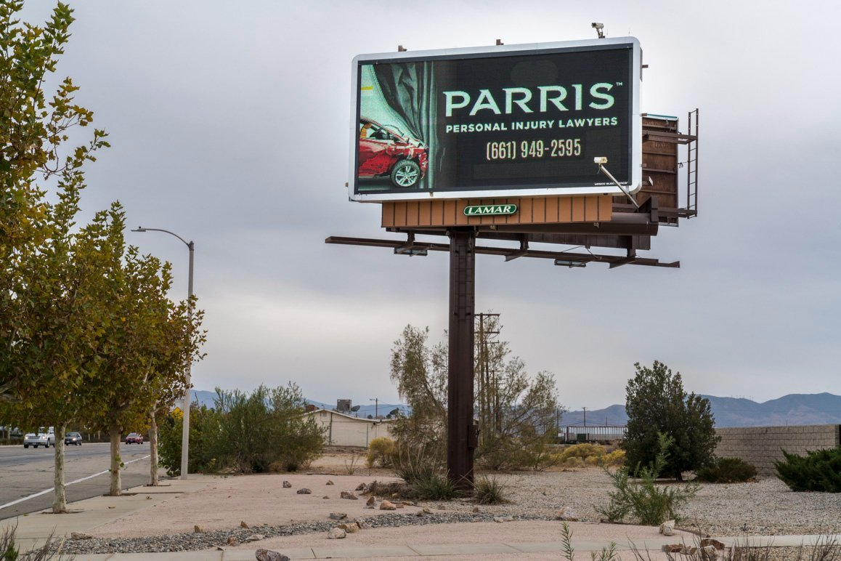

<https://www.kcet.org/shows/artbound/the-shifting-demographics-of-antelope-valley-and-developments-consequences>

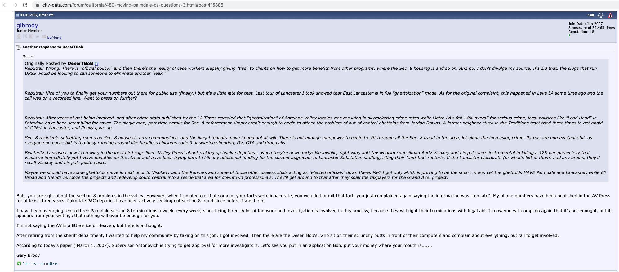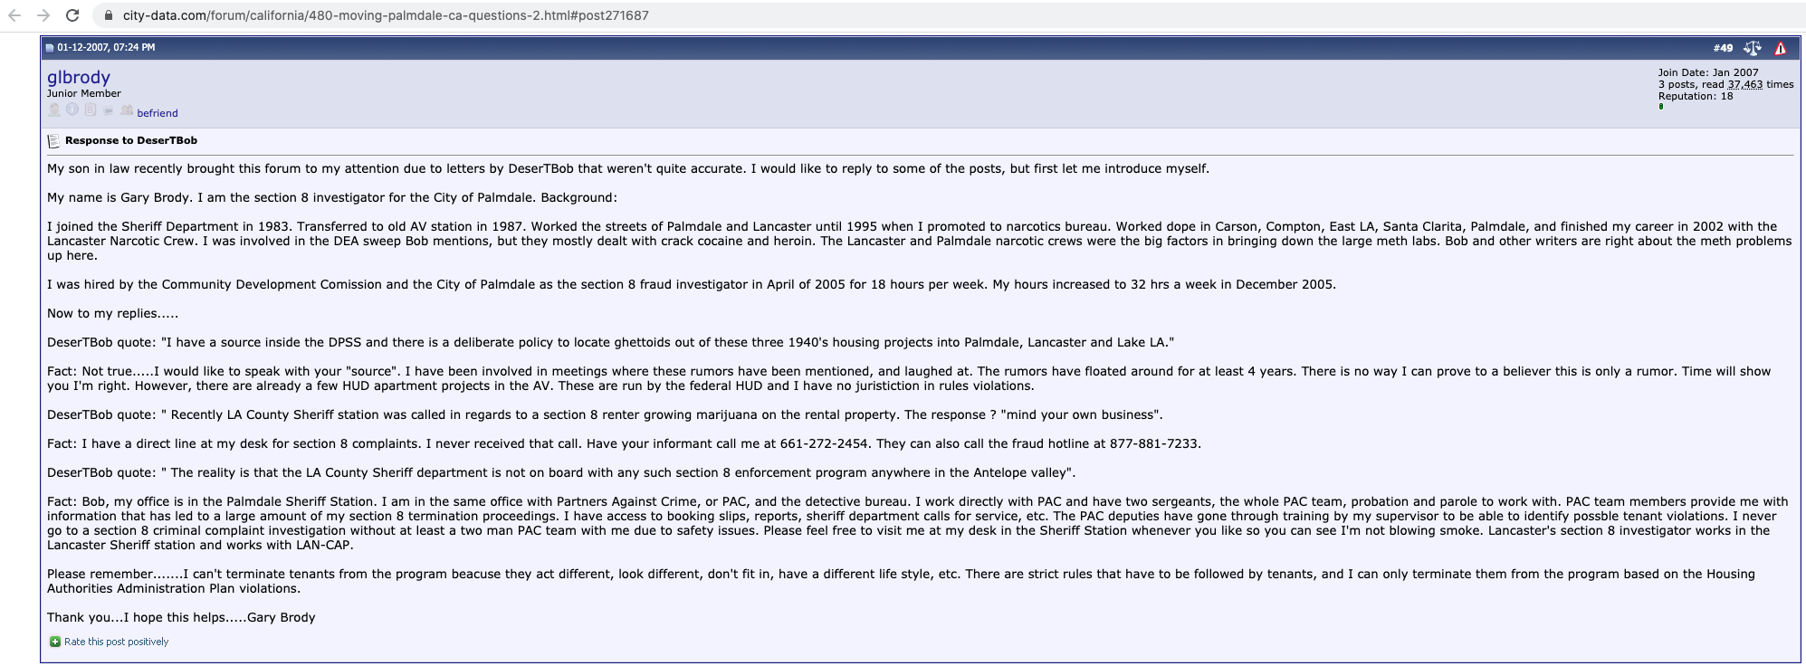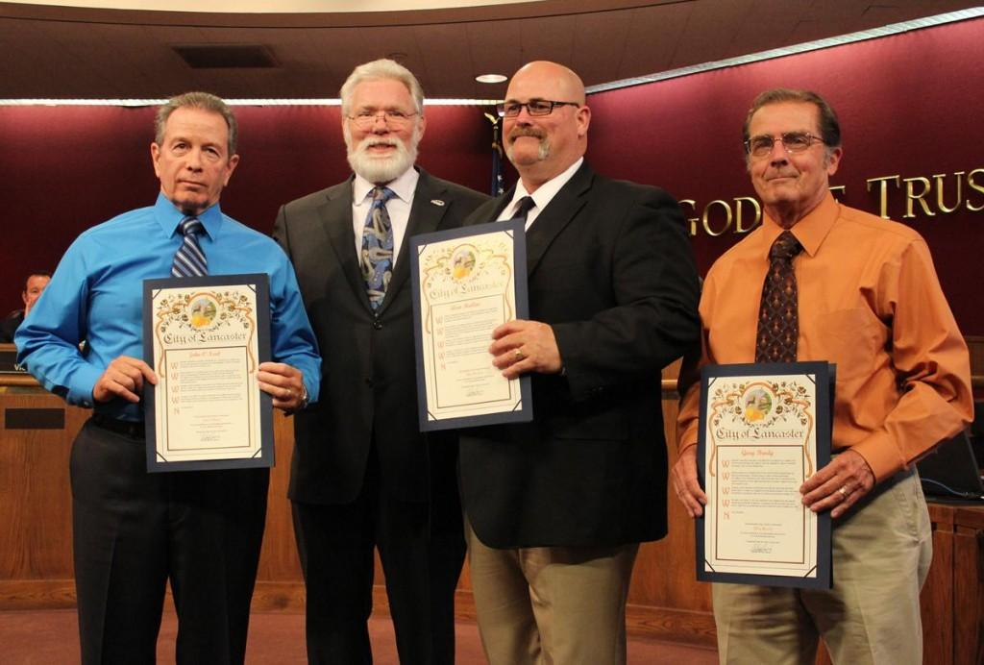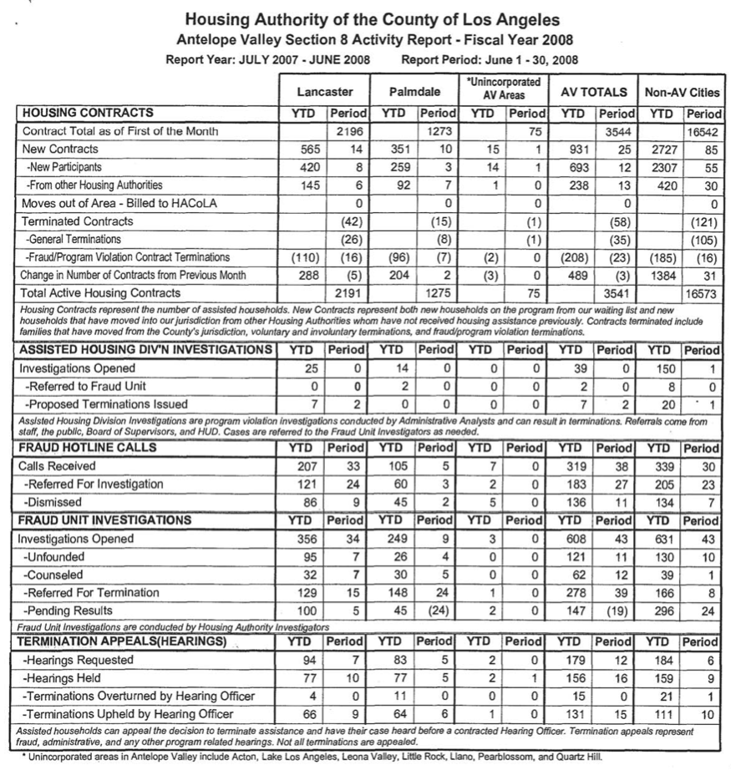



Lancaster residents attend a County Board of Supervisors meeting to advocate for policing Section 8 Voucher tenants. Mayor Parris sits in the 3rd row.

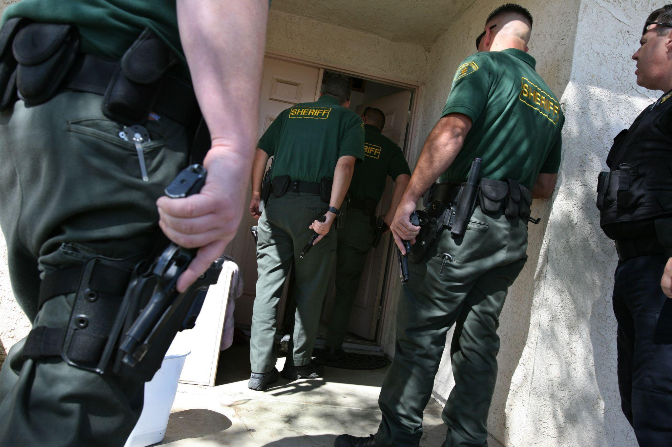

An inspection of a Section 8 tenant

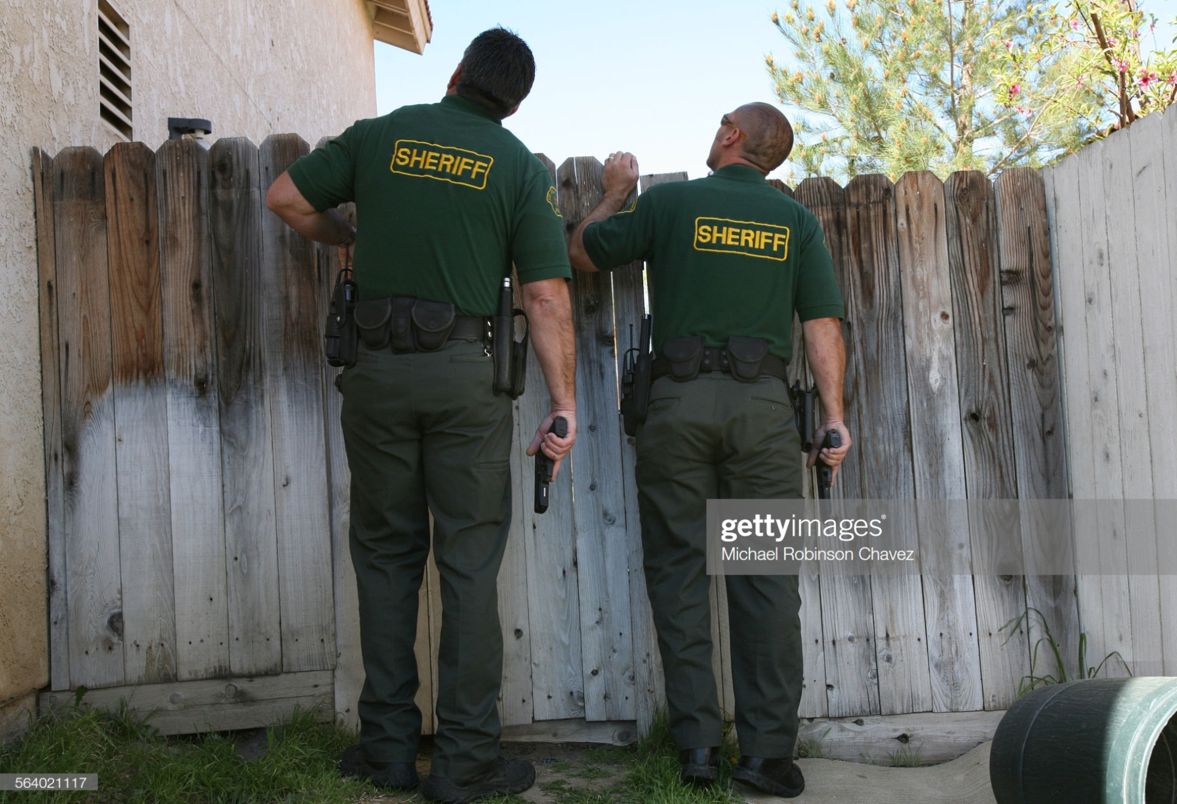

1. Times-Advocate (Escondido, California) · Wed, Oct 25, 1989 · Page 39
2. Judith Cummings. *California City Outgrows its 'Boom or Bust' Cycles; The Talk of Palmdale*. New York Times. February 9, 1982, Section A, Page 14 https://www.nytimes.com/1982/02/09/us/california-city-outgrows-its-boom-or-bust-cycles-the-talk-of-palmdale.html?searchResultPosition=1
3. ibid
4. ibid
5. North County Times (Oceanside, California) · Wed, Dec 29, 1999 · Page 32
6. Gilmore, Ruth Wilson. *Golden gulag: Prisons, surplus, crisis, and opposition in globalizing California*. Univ of California Press, 2007.
7. County of Los Angeles Sheriff Civilian Oversight Commission. “Mira Loma Women’s Detention Center Project Update.” May 15, 2018. <https://coc.lacounty.gov/LinkClick.aspx?fileticket=hJeTWcPA-Vo%3D&portalid=35>
8. <https://web.archive.org/web/20090808115142/http://www.cdcr.ca.gov/Visitors/Facilities/LAC-Institution_Stats.html>
9. Weaver, Vesla M. "Frontlash: Race and the development of punitive crime policy." *Studies in American Political Development.* 21, no. 2 (2007): 230-265.
10. Sometimes having a car was the problem - it signaled you were financially well off enough to work and pay full rent. Other times not having a car was the problem - it signaled that you were too poor or too lazy to work and be a productive member of society.
11. <https://www.avpress.com/news/parris-seeks-fifth-term-as-mayor/article_72bf00aa-7c6a-11ea-9228-3bd6baab6e3e.html>, <http://www.metnews.com/articles/2019/POYperris011119.htm>
12. Bob Wilson. “City to Ready Responses for Section 8 Idea.” AV Press 10.12.2009
13. https://www.cityoflancasterca.org/our-city/departments-services/finance/business-licensing/rental-housing-business-license-lancap
14. STAFF REPORT. City of Lancaster, California. 3/24/09. From: Elizabeth Brubaker, Housing & Neighborhood Revitalization Director. Subject: Presentation on Results of the Feasibility of Developing a Multi-Jurisdiction Housing Authority to Administer the Housing Choice Voucher Program.
15. Bob Wilson. “No Section 8 Cut for Truancy - Yet.” AV Press 02.03.2011
16. Bob Wilson. “Lancaster Scrutinizes Section 8 Data.” AV Press 04.25.2011.
17. ftp://www.legislature.ca.gov/pub/11-12/bill/sen/sb_0651-0700/sb_660_cfa_20110407_144750_sen_comm.html
18. I cannot prove beyond a doubt that the two entities were the same.
19. (Rieder 1985, p.171)